Call for applications: Migration Media Award 2019

* 1ST MARCH 2019

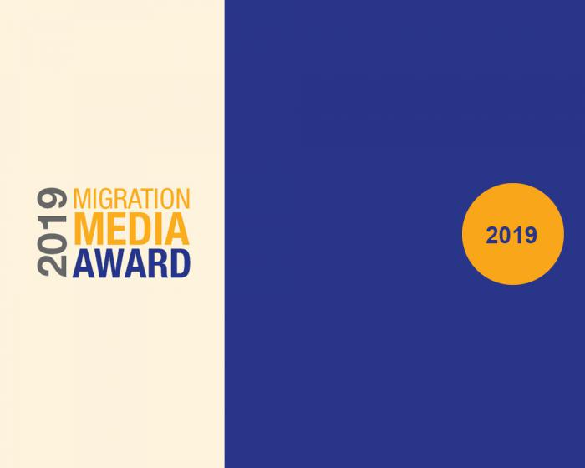

**Update:** At the request of many applicants, the 2019 edition of the Migration Media Award will stay open for applications until **15th April 2019.**

The Migration Media Award ([www.migration-media-award.eu](http://www.migration-media-award.eu)) funded by the European Union, rewarded over 35 stories in 2017 and 41 in 2018 showcasing journalistic excellence on migration in the Euro-Mediterranean region.

The 2019 edition will reward **constructive journalism**, reflected through human interest and analytical stories, resulting from time-intensive, un-sensationalistic, in-depth reporting and contributing to balance the narrative on migration, making it more evidence based, nuanced and less polarising.

In April/May 2019, a Jury will select up to 60 applicant journalists to receive mentoring and funding from 750 to 7000 euros for the production of a second story by October 15, 2019. Among these, in November 2019, the Jury will select up to 48 recipients of the 1st, 2nd, 3rd prizes of the Migration Media Award in the 6 media formats and 3 language categories.

Journalists or media houses based in either EU countries or Neighbourhood South Countries are eligible to apply via the [online application form](http://www.migration-media-award.eu/index.php/en/application-form) by submitting an already published journalistic story between **15 May 2018 and 31st March 2019**along with a proposal for a second production. Both productions, actual and intended, need to address one or more of the following themes in **the Euro-Mediterranean region:**

* **Diaspora**
* **Labour migration**
* **Vulnerable groups**
* **Legal and irregular migration**

1. The entry must be submitted in one of the 3 languages of the Award scheme: English, French or Arabic. Stories in other languages from the Euro Mediterranean region must be accompanied by a translation into either English, French or Arabic.
2. Multiple entries are accepted in separate and complete applications in the following formats: video, radio, print, online, multimedia and photo.
3. Mid to long length formats are requested and therefore short news items will not be eligible.
4. A budget to produce the second story must be submitted along with copyright waiver and a letter of intent from a media outlet to publish it.

Please note that candidates may not submit a story already supported by the MMA 2017 and 2018.

Interested applicants should check the Eligibility & Application section of the [www.migration-media-award.eu](http://www.migration-media-award.eu) prior to applying. In case of any questions, kindly contact: [contact@migration-media-award.eu](mailto:contact@migration-media-award.eu).

This award is a collaboration of the Directorate-General for Neighbourhood and Enlargement Negotiations (DG NEAR) funded programs Euromed Migration IV implemented by the International Center for Migration Policy Development (ICMPD) and the Open Media Hub led by the Thomson Foundation, in partnership with the Ministry for Foreign Affairs of Malta and the European Asylum Support Office (EASO), and with the support of the European Investment Bank (EIB).